Video Game Central
ANALYSIS AND DESIGN DOCUMENT



Team 7
Daniel Rosendo
Muna Khan
David Kim

Contents
Contents 2
Introduction 3
System Architecture 4
System Overview 4
Architectural Design 4
Decomposition Description 4
Design Rationale 4
Human Interface Design 4
registration 5
INPUT & OUTPUT 6
Actions 6
Pre and Post Conditions 6
Validation 7
LOGIN 7
INPUT & OUTPUT 7
Actions 8
Pre and Post Conditions 8
Validation 8
CHANGE PASSWORD 8
INPUT & OUTPUT 9
Actions 9
Pre and Post Conditions 10
Validation 10
Component Design 10
Entities 11
Data Design 11
Data Description 12
Registration / Authentication 12
DATABASE Dictionary / SCHEMA 13
Registration / Authentication 14
Full DAtabase Model 15
Requirements Matrix 16
Appendices 16

Description: The ADD is the second document that each group will submit regarding the class project. Each group will work with one (1) feature per team member. For each feature, you will need to design each of the “Use Cases” you worked for the SRS document.
The document should include the following items:

Introduction
- Introduction
  - Purpose
The purpose of this document is to present a detailed description of The Game Hub application. It will explain the features present, the purpose, the GUI, and the constraints under which it must operate and how the website will react under different conditions.
  - Scope
This project will be a platform for users to find games, tutorials and walk through, upcoming games, and the latest news. The target audience are those who play games, follow gaming news, and need help with games they are having trouble in. The website will be accessible through any web browser with internet connectivity.
  - Definitions
User – A member of the game central website who is in the database.
PS – Sony PlayStation Gaming Console
XBOX – Microsoft Gaming Console
Wii – Nintendo Gaming Console
Switch – Nintendo Gaming Console
PC – Personal Computer
Mobile – Smartphone Gaming
HTML - Hypertext Markup Language.
SQL – Programming language to create database.
  - References
Sony PlayStation:
(https://www.playstation.com/en-us/)
Microsoft:
(https://www.xbox.com/en-US/?xr=mebarnav)
Nintendo:
(https://www.nintendo.com/)
  - Overview
This SRS document contains the introduction, overall description, user requirements, system requirements, functional requirement, system models, and non-functional requirements. SRS document is organized by first stating all the requirements such as user systems and functional requirements, then presents all the system models for back end functionality and all the non- functional requirements.
- Definitions and Acronyms:
VGC – Video game central
PS4- PlayStation 4
PC- Personal Computer
NDS- Nintendo Dual Screen
RPG- Role playing game
FPS- First person shooter
MMO – Massively Multiplayer Online. ...
MMOG – Massively Multiplayer Online Game. ...
RPG – Role-Playing Game. ...
ARPG – Action Role-Playing Game. ...
MMORPG – Massively Multiplayer Online Role Play Game. ...
TBS – Turn-Based Strategy. ...
RTS – Real-Time Strategy. ...
ARTS – Action Real-Time Strategy.
AMD - Advanced Micro Devices
FPS – Frames per second

System Architecture
(This section is only one per group)
- Write a High level description of the system involving modules and components.
This system is created for all types of games. This is system helps user to find games and learn about the updates, news, information through discussion/forums and chat rooms which will allow them to communicate with other gamers about the games. The system will give more preferences to users who are logged in or who has an account in the website. There will be walk through tutorials to help gamers understand how one game will work. The components if the system is user view of the website, admin view of the website which can be interchangeable with the system. The search engine component will help find a game, find forums/discussions/ chat rooms of the game.
- Include Context diagrams with description of the architecture planned.
Layered Architecture Model
- User Interface Layer: will include classes, function, and controls that will be in charge for communications with the user.
- Business Logic Layer: will contain of classes, functions, and controls that will take the users’ input for the processes to achieve the required results.
- Persistence Layer: will include server operations that use the user input and business logic to access data in server’s database and perform system operations.
- Database Layer: For security purposes, only the predefined system layer processes will be able to access it.

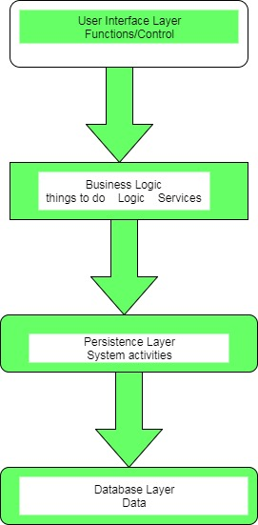

System Overview
Give a general description of the functionality, context and design of your project. Provide any background information if necessary.
This website was developed for gamers. The main purpose of this website is to allow gamers a way to interact, discuss, find games, and walk through tutorials. The website includes features such as chat, forums, reviews, news, game catalog, and walk through tutorials. An example of how a user can use this website is; John wants to find a game called Grand Theft Auto and wants tutorials. John goes on to our website accesses the game catalog to search the game. He then goes through tutorial page for that game. He also decides to access the forum to post questions he has about the game. He also has a friend who has an account on our site and uses the chat feature to talk with him. John could not find another game, so he used the search feature of the game catalog to find the game.

Architectural Design
- Develop a modular program structure and explain the relationships between the modules to achieve the complete functionality of the system. This is a high level overview of how responsibilities of the system were partitioned and then assigned to subsystems.
- Identify each high level subsystem and the roles or responsibilities assigned to it.
  - Describe how these subsystems collaborate with each other in order to achieve the desired functionality.
  - Don’t go into too much detail about the individual subsystems. The main purpose is to gain a general understanding of how and why the system was decomposed, and how the individual parts work together.
- Provide a diagram showing the major subsystems and data repositories and their interconnections. Describe the diagram if required.

Decomposition Description
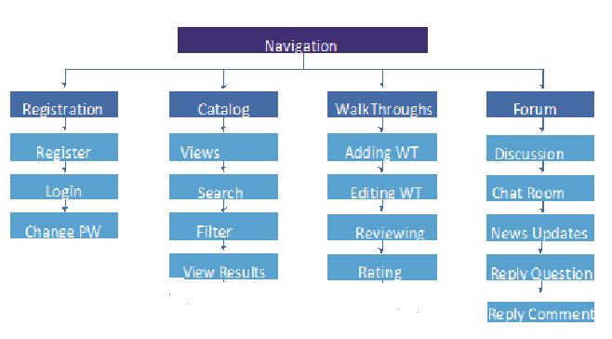.

Design Rationale

The Game Central website will use layered Architecture, considering it permits the advancement group with more proficiently create the modules of the website, and gives a simpler support, and provides an easier care by separating concerns such as visual (user interface), logic (business logic), system processes, and database operations.
Concerning illustration, the group will start from the Creating the lowest part layers together, they can quickly differentiate. Furthermore, move under Creating their modules dependent upon those built as a relatable point lowest part layers. As different architecture designs were considered for the game central website, Layered Architecture seemed to follow to the most problem frames known, such as:
- Data Display: The User Interface layer will help the information be represented in the most complete way, and be available to most users on the website.
- Simple Work Parts: the useful areas of the website are broken down into simple work parts which are use cases.
Data central model was something that we wanted to pick at first place, but we weren’t sure if that would work. It was working at first place, but the features and use cases were all connecting to database it was categorized. Layered architecture was better and easier to understand step by step.

Human Interface Design
- Detailed definition of the system requirements specification for each use case. Each use case should be mapped to a component (or page) with the expected input and outputs, the Actions taken as part of the component execution and the pre-conditions.
  - Overview of User Interface. Describe the “page” or “form”
  - Screen Images (wireframes, mocks, drawings). Draw a mock or wireframe of the page/form
  - Describe page/form behavior: Screen Objects and Actions: should include all buttons, input fields, menu options:
  - Describe each Input and Outputs (every field for every page is included) with data types/length/attributes
  - Actions or execution: Describe the business rule and algorithms for the actions
  - Pre and Post Conditions: Similar to the SRS, make sure all assumptions are accounted for
  - Validations: Describe all rules and every field that must be validated. For example, which fields are required, what kind of validation must be included (valid phone number or SSN or email address)
  - Different actors cases need to be included (client and administrator)

Account Management Feature

Forums/ Discussion

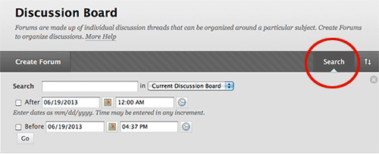
The Discussion Board will enable registered users to create a post or reply to posts. This module will be accessible via the navigation bar under forum tab. Users will be able to access discussions by certain time frame by searching date. As noted on the SRS, any user can view the discussion board, but only registered users can create a post, or reply to a post. Users who attempt to reply or create a post will be prompted to log-in.

INPUT & OUTPUT

Input:
- Search game tag or games: String representing name of the game, game tags, types of games, or their categories.
- Search by time frame: users can enter dates range of what post/ discussion to find on certain game.
- Create Forum: If there is not a forum in the system then registered user can create one.

Output:
If there is anything exist by the tag or name of the game user can access the discussion or else, they will receive the discussion not found page. Then the user could go ahead and search or create a new discussion by clicking at create forum.

Actions
Upon submitting the form, the system will validate that fields have input, and show list of discussion that exist by such name.
If a discussion exists, then send user to that discussion
If there is no discussion, user can create one.

Pre and Post Conditions
Pre-conditions: User has not registered with the system already. System should be able to view the discussion.
Post-conditions: Users should be able to reply in discussion board.

Validation
Upon uploading the comment, the system will validate that the users/admins credentials are valid.
- If the validation is successful, the system will upload the comment to the database.

Chat Room

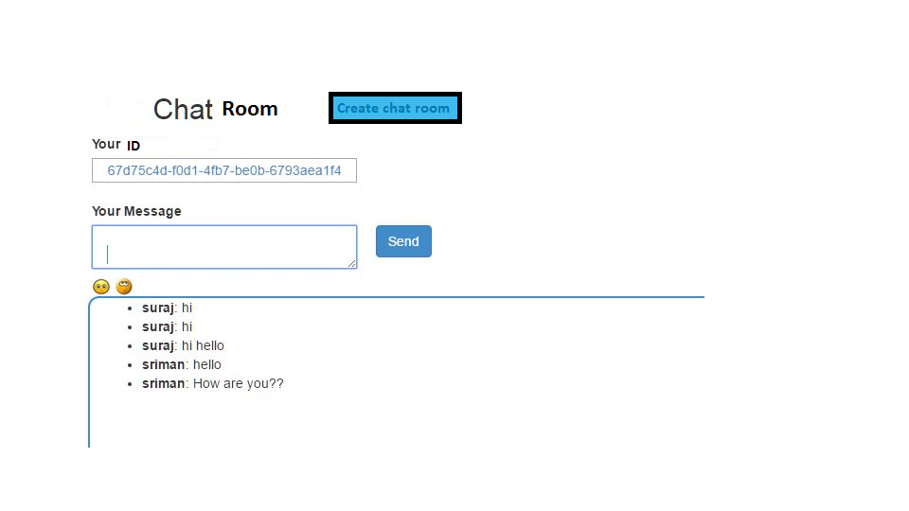
The chat room will allow registered users to join a chat room depending on their game. This module will be accessible via the navigation bar under forum tab. Users will be able to access chat room by searching the chat room for a game they want. They can also create one. As noted on the SRS, any user can view the chat rooms, but only registered users can create a chat room, and chat with other users. Unregistered users who attempt to reply or create a post will be prompted to log-in.

INPUT & OUTPUT

Input:
- Search game tag or games for chat Room: String representing name of the game, game tags, types of games, or their categories.
- Join Chat Room: Users can join different chat room
- Create Chat Room: user can create chat rooms and invite their friends to the chat room.

Output:
If there is anything exist by the tag or name of the game user can access the chat room or else, they will receive the chat room not found page. Then the user could go ahead and search again or create a new chat room by clicking at create chat room.

Actions
The system will validate that fields have input, and show list of chat room that exist by such name.
If a chat room exists, then send user to that chat room
If there is no chat room, user can create one.

Pre and Post Conditions
Pre-conditions: User has not registered with the system already. System should be able to view the chat rooms to the user.
Post-conditions: Users should be able to chat in chat room.

Validation
- If the validation is successful, the system will upload the relies in the chat room to the database.

Game News & Updates
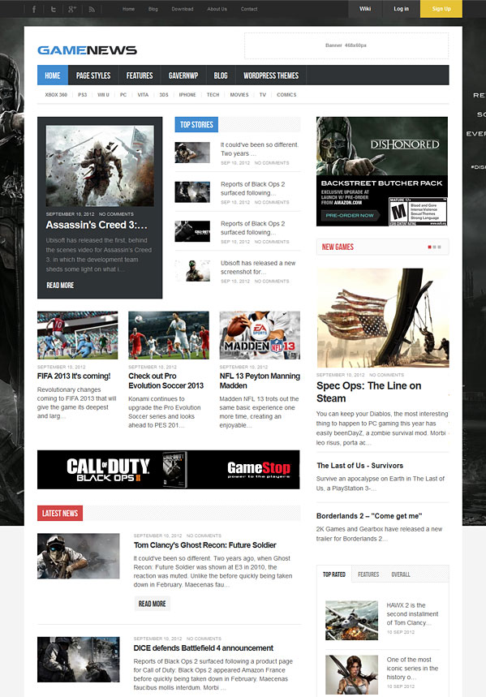

The news page will allow user to read updates on games, access news about games. You can access the news page via the navigation bar under forum tab. Users will be able to access news page.

INPUT & OUTPUT

Input:
Click news page: search game news, articles, look up by games’ name.

Output:
If there is anything exist by the tag or name of the game user can access the articles or just read news about the games on main page of the news.

Actions
System should be updating and uploading news

Pre and Post Conditions
Pre-conditions: Admin didn’t upload news on the page.
Post-conditions: News have been updated often.

Validation
- If the validation is successful, the system will upload the news on the news web page.

Registration

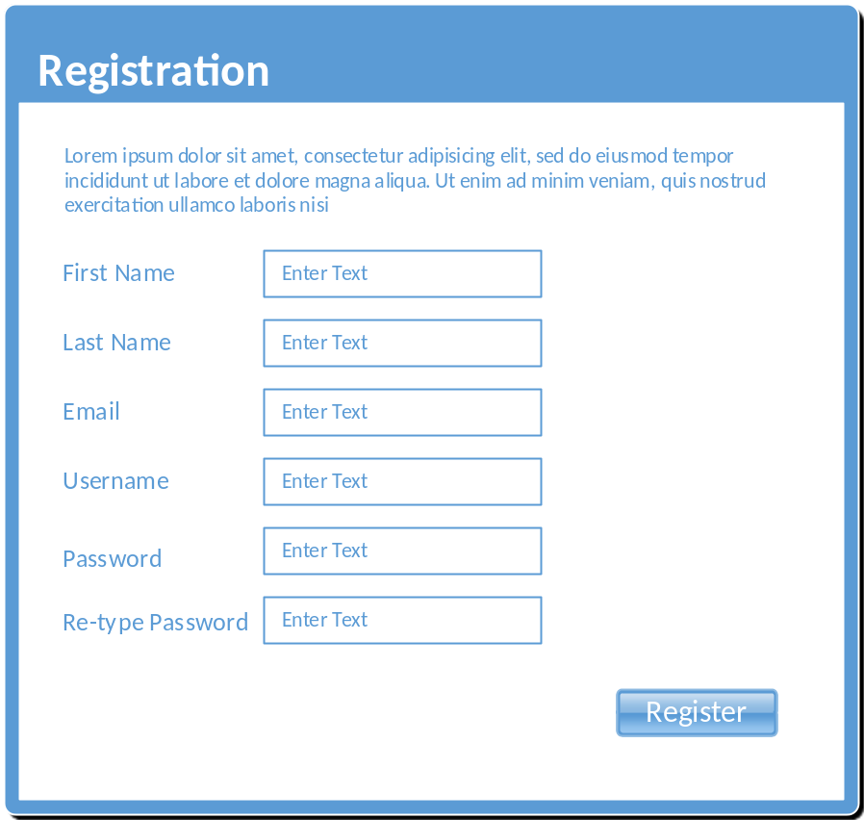
The registration page will allow new users to register with the system. The user must enter all fields before submitting the form.

INPUT & OUTPUT

Input:
- First Name: String representing the first name of user. Minimum of 1 and maximum of 50 characters.
- Last Name: String representing last name of user. Min 1 and maximum 50 characters
- Email: User’s email address used for communication and verification. Should match standard email pattern “name@server.com”. Minimum of 10 characters, maximum of 50 characters.
- Username: string representing the username can be a minimum of 6 characters and a maximum length of 20.
- Password: Also a string. Must be a minimum of 8 characters and a maximum of 20. Must contain on capital letter and one number.
- Re-enter Password: matches Password field. Used only for verification of password.

Output:
Upon successful creation of user, the system will display a welcome message or a warning message. In addition, if the data entered is not valid, the system will show a list of the fields with invalid data in red font.
Possible messages:
Successful: “Welcome [First Name] [Last Name]. Thank you for registering with us!”
Failed: “There is an error with your information. Please review the fields highlighted in red and re-enter the information”

Actions
Upon submitting the form, the system will validate that all required fields have input, and that each field matches the required data in the required format.
If the validation is successful, the system will run a query to store the user’s information in the database.
If the validation failed, the system will abort transaction and return an error message for each invalid field.

Pre and Post Conditions
Pre-conditions: User has not registered with the system already. The system should validate that the email and username are unique within the stored user values.
Post-conditions: User record is stored successfully. A user session is created.

Validation
The following validations will be performed on the submitted data:
- First Name, Last Name: fields must be at least the minimum specified length and no more than the maximum length.
- Username: must be unique
- Email: must be unique and must meet standard email address format
- Password: Must meet standard strong password policy. The password must be stored using a secure mechanism that will prevent unauthorized access. All passwords will be hashed and stored as such in the database.

LOGIN Use Case
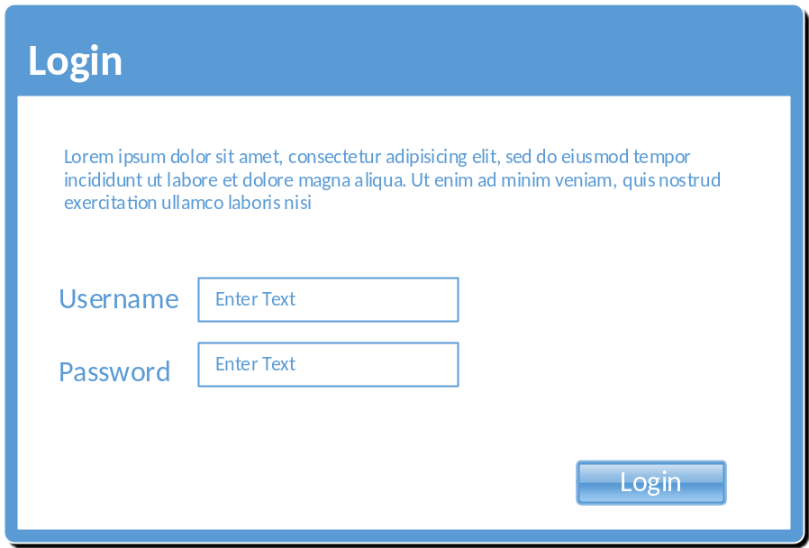
The login page will allow students/faculty to access the system’s features. They can also rest their password or unlock their account.

INPUT & OUTPUT

Input:
- Username: string representing the username can be a minimum of 6 characters and a maximum length of 20.
- Password: Also a string. Must be a minimum of 8 characters and a maximum of 20. Must contain on capital letter and one number.

Output:
A session is created for the successful logged in user to access information granted to the specific user role. Also a message welcoming the user or an error (depending on the credentials provided)

Actions
Once the user has entered their user name and password, the “Login” button will prompt the site to authenticate the user. Their role will be determined and they will be granted access to the modules available to that class of user. Based on the assigned role, the user might be re-routed to the faculty page or the student page.

Pre and Post Conditions
Pre-conditions: Faculty and students both require a valid user name and password, the user name will be assigned upon acceptance or employment to the institution.
Post-conditions: Successful entry of credentials will result in a portal page. Unsuccessful entry of credentials will result in an error page, where the user is required to re-submit credentials.

Validation
Both the user name and password will be validated by comparing them to the specific user credentials stored in the database.
Password Security: The password must be stored using a secure mechanism that will prevent unauthorized access. All passwords will be hashed and stored as such in the database.

CHANGE PASSWORD Use Case
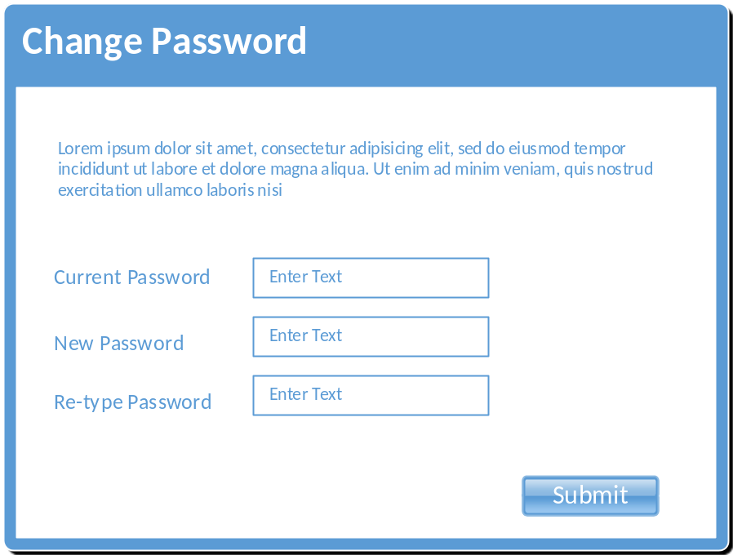
The Change Password page will allow the user to change their password by entering the current one, and the new password.

INPUT & OUTPUT

Input:
- Current Password: String. Must be a minimum of 8 characters and a maximum of 20. Must contain on capital letter and one number.
- New Password: Also a string. Must be a minimum of 8 characters and a maximum of 20. Must contain on capital letter and one number.
- Re-type Password: Same requirements as New Password

Output:
If the user enter the correct “current password”, the system will store the new password and return a “Successfully change of password” message.

Actions
Upon submission of the form, the system will validate the user has entered the correct password. To do so, the system will use the current session username and retrieve the current password from the database. The “Current Password” entered will be verified against the stored password and if successful, it will also validate both “New Password” and “Re-type Password” values are identical.
If all validation passes, then the system will update the user account with the new password entered.

Pre and Post Conditions
Pre-conditions: User is already registered, and the account is active.
Post-conditions: Successful transaction will update the user’s password to the specified new values.

Validation
Current password will be validated against the stored password. New password will be validated against the “Re-type password” value, which should match. Also, new password must meet strong password policy.
Password Security: The password must be stored using a secure mechanism that will prevent unauthorized access. All passwords will be hashed and stored as such in the database.

Component Design
Forum and Discussion Component Design
Discussion/ Forum
+
UserTypeID
userName
+
password
+
Discussion
GameTags
+
+
GameTitle
userID
+
GamerUserID
+
dateTime
+
postQuestion
+
replyToQuestion
+
replyToComment
+
dateCreated
+
Chat Room
+
GamerID
+
InviteFriends
+
CreateChat ChatRoo
+
GameTitle
Game News
GameUpdates
+
LatestNews
+
+
NewsDates
dateCreated
+

The main responsibility of UserType class is to check if a user entered the site is a registered user. The userType class for members allow one to register, create account access further pages. The discussion class allow user to discuss about games and respond back to other gamers and chat about the game and read news on latest games. The UserType admin class is for admin to make changes to other pages and check credentials of users and make changes in the database. The main requirements for this class is logging into the account.

Entities
Discussion: The discussion class is the base class for all the user information. The discussion class is responsible for the user’s unique ID which the user gets while he/she has posted or commented to any questions.
Attributes/Fields:
- User ID: unique identifier for each user.
- Username: a unique string chosen by the user to access to the system.
- Password: a unique password string to provide security to the users account.
- Game Title Text: a string representing the title chosen by the user for posting the discussion or responding to the users for a certain game.
- Game Tag: a string representing what the user has named or gave a tag to a game to access its discussion.
- Post Questions: The question or problem the user is facing.
- Reply to Questions: The admin is responsible for replying to the questions asked by the user and the other users can answer.
- Reply to Comment: The admin is responsible for replying to the comment posted by the user.
- DateTime: The date and time the user created the post or comment, or admin replied to the post or comment.
- UserType: It defines the type of the current user.
- GameID: int assigned to a game
- InviteFriends: tab where you can add other users to be part of the chat room.
- GameUpdates: A page of recent news/ updates about a game.
Relationships
- UserType: Each user has one to one relationship with a type entity.
UserType
Entity that identifies one of the possible types of users. The possible options are: guest, member, administrator.

Account Management Feature
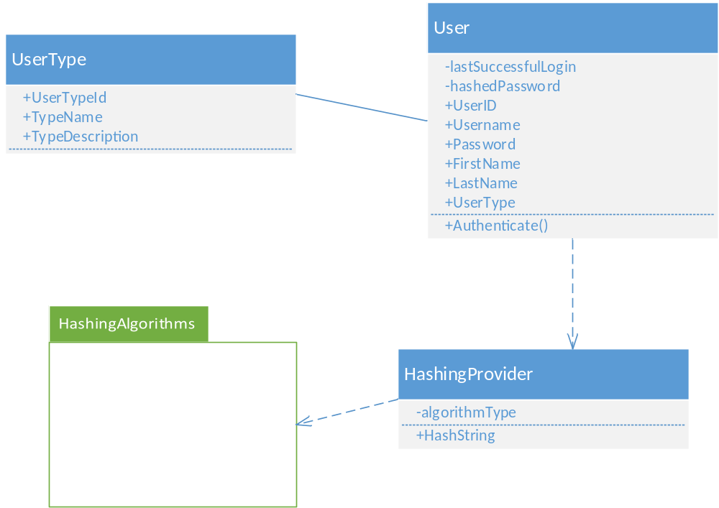

Entities
User: The User class represents both customer and staff entities. It is the base class for all user information. This class is responsible for managing the user personal information as well as defining the formatting of names.
User Attributes/Fields:
- User ID: unique identifier for a single User instance
- FirstName: The first name of the user
- LastName: The last name of the user
- Email: a string representing a valid email address in the form of [account]@[domain].[suffix]
- Username: a unique string chosen by the user to gain access to the system
- Password: a string representing the password selected by the user to gain access to the Web site. It should be no less than 8 chararcters
- UserType: An association to the UserType entity. It defines the type of the current user instance
Relationships:
- UserType: Each user has a one to one relationship with a type entity.
- HashingProvider: The User object will depend on the HashingProvider entity which will hash the passwords for the current user object.
UserType: Entity that identifies one of the possible types of users. Possible options might be “customer”, “admin”, “guest”
HashingProvider: This object will be responsible for hashing the user passwords using one of the standard algorithm. The “provider” will depend on a third-party library for the hashing algorithm.
HashingAlgorithms: This package is TBD based on hashing requirements.

Data Design
One per module/feature of the following: ERD 3
User

Admin

Invite

Gamer

Create discussion

Respond

Discussion

Chat Room

Game News

Website

Post

1

1

1

n

Discussion

Chat Room

Game News

News
s

Invite

Discuss

Reviews

Respond

UserType

Data Description
- Entity-relationship model (ER model) for each use case
- Include a classic ERD (Entity Relationship Diagram) model for each use case, and make sure you added each entity with its relationship and attributes.
- Make sure that all relationships are defined and accounted for
- Attributes are defined with natural/primary keys
- Model is complete or extensive

Account Management Feature
From the below diagram, we identified a relationship between a user and his/her type. The possible types will be Administrator and Customer. The relationship “IsType” does not include any specific attributes.
Another relationship for the user is the Game Reviews. In this particular relationship, we have unique attributes that are not part of the user and neither are they part of the game. Those attributes are only related to the user review of a game. For example, the Review Description and the When Reviewed attributes are not part of the user, but they do describe the relationship of the user and game through a review.
Please include in the diagram a numeric quantity on the relationships.
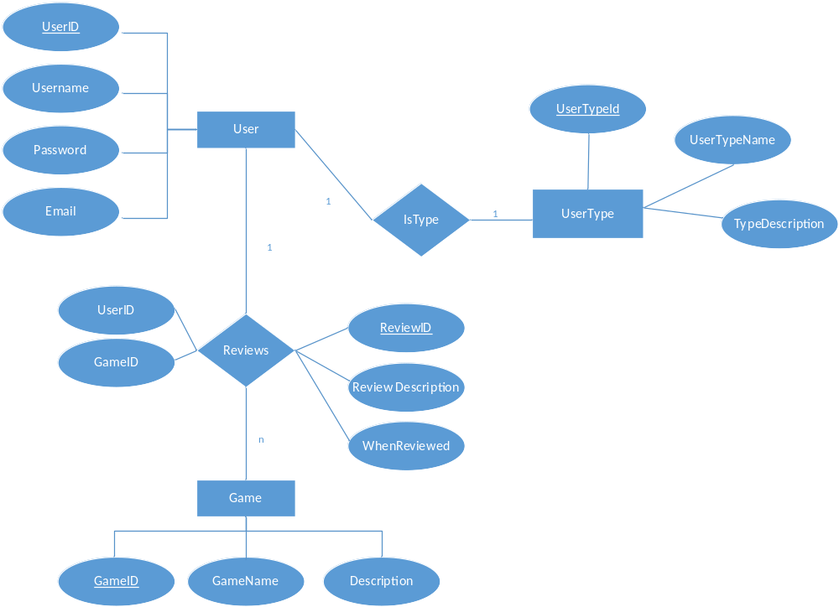

DATABASE Dictionary / SCHEMA
Guidelines:
Schema is well defined for all entities in the ERD
- Fields are well defined, including the data type and the description
- Primary and Foreign keys are defined and included in the diagram
- Relationships are well defined
- Define each table needed for each component or module
- Table fields should be described extensively (data type + dictionary/meaning).
- Identify all primary keys and foreign keys for each table

Discussion & Forum Feature
The following tables are defined for the Discussion/Forum module
User Table

Entity | Type | Value | Description
userName | String | Not null | PK. Unique identifier of a user.
Password | String | Not null | Unique code created by user to enter system
DateCreated | String | Not null | Date given by system once something is posted on such date
GameID | Int | Not null | Unique ID for game
InviteFriends | method | method | User can add other gamers.
CreateChatRoom | method | method | Single chatroom created y gamers for games.
GameTitle | String | Not null | Name of the game.
GameTags | String | Not null | Unique tags for games
PostQuestion | String | Not null | Gamers can post questions
PostComment | String | Not null | User can comment
GameUpdates | String | Not null | Updates about the game
LatestNews | String | Not null | News on games

Account Management Feature
The following tables are defined for the Registration/Authentication module
User Table

Entity | Type | Value | Description
user_id | INT | Not null | PK. Unique identifier of a user.
user_type_id | INT | Not null | FK. Relationship key to the User_Types table
user_pw | varchar(50) | Not null | User’s password HASH
first_name | varchar(30) | Not null | User’s first name
last_name | varchar(30) | Not null | User’s last name
DOB | Date | Not null | User’s date of birth
SSN | varchar(9) | Not null | User’s social security number
Phone | varchar(10) | Not null | User’s phone number
Email | varchar(50) | Not null | User’s E-mail address
Address | varchar(50) | Not null | User’s home address
City | varchar(20) | Not null | City
State | varchar(2) | Not null | State
Zip_code | varchar(5) | Not null | Zip code

User_Types Table

Entity | Type | Value | Description
user_type_id | INT | Not Null | PK. Unique identifier of a user.
type_name | varchar(50) | Not null | The name of the user type
type_description | varchar(50) | Not null | Description of the user type and its uses

Full DAtabase Model
Full entity relationship for ALL MODULES assigned to your group. No need to include dictionary. This entity relationship diagram should include tables for ALL the use cases presented in the SRD. This is the only section of the document where you will be using info from the fall your use cases.
Guidelines:
Include ALL assigned modules
- Include in your diagram
- Relationships are well defined
- Table names
- Fields
- Primary keys (PK)
- Foreign keys (FK)
- Relationships
SAMPLE DIAGRAM (NOT APPLICABLE FOR THIS PROJECT)
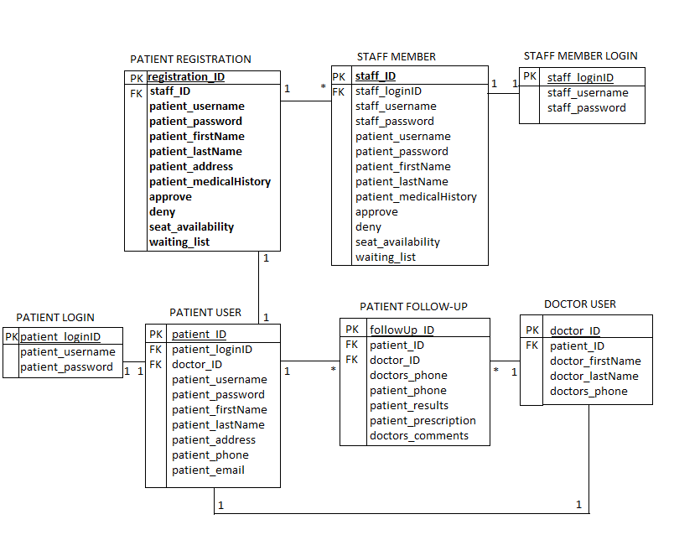

Requirements Matrix
For this section, simply provide a cross-reference that traces components and tables to your original requirements from your SRS document.
Use a structured or table format and identify each requirement with a design component.
You can refer to the requirements by Module/Use case or if you use a numeric format in your SRS, simply reference the requirement number.
For the component matching the requirement, you can use a page number or section number. For example:
Module | Use Case | Design Component
Account Management Module | Registration | User Interface: Registration  ERD Diagram 1  Component Model: Account Management  DB Schema section1
 | Authentication | User Interface: Login  ERD Diagram 1  Component Model: Account Management  DB Schema section1
 | Change Password | User Interface: Change Pwd  ERD Diagram 1  Component Model: Account Management  DB Schema section1

Appendices
Include in this section any relevant information to the design of the project that you think will be necessary to the development of the modules.

Security
The Game central website will implement the following features to protect the software and the user from accidental or malicious occurrences, and to maximize the privacy, integrity, and accessibility of information.
- Utilize Antivirus software on the server:
- Third Party Antivirus Software, depending on the server OS
- Implement Denial of Service Protection:
- Third Party Server Firewall solutions, depending on the server OS
- Log member’s activity:
- Implement server script that will track which IP the member uses to log in
- Enforcing password requirements:
- Apply hashing for storing and transmitting passwords:
- Before the passwords will be transmitted, they will be hashed using SHA-2 algorithm on the client machine. The resulting value will be transmitted to the server, assigned as user password and stored in the database.
- Assign certain functions to different modules:
- Every major function in the website will reside within its corresponding module. This module will contain only the functions and variables to perform the re-described tasks.88
- Restrict communications between some areas of the program:
- As modules will be focused on specific tasks they need to accomplish, they will only connect to other modules they are designed to communicate with. All other connections will be eliminated.
- Check data integrity for critical variables:
- The type and characteristics of the variable which will be used to store user input will be strictly predefined to avoid system failures and prevent malicious exploitations.

Maintainability
- The game central website will implement the following ideas in orders to maximize the maintainability of the product:
- The design will be based on the Separation of Concerns theory:
- This will allow the easiest and most efficient way to modify particular elements without affecting the others.
- Developers will be encouraged to the most clear, easy, and comprehensive coding:
- This will allow the maintainers to easily update or modify the code if necessary.
- Developers will also be encouraged to utilize extensive comments:
- This will help the future maintainers to comprehend the logic of the software and manage the appropriate maintenance procedures.
- Implement extendibility:
- The website is projected to grow and develop with contribution of growing number of users. Therefore, the website must be able to adjust to the growth, and the code must favor the implementation of new functions.
- Provide testability options:
- The website will need to provide testing methods for different functions included.

Portability
- The game central website will ensure its portability through the compatibility factors:
- Support of all modern platforms:
- iOS
- Android
- Windows
- Support for different screen sizes:
- Large (minimum 960 pixels)
- Medium (minimum 470 pixels)
- Small (minimum 426 pixels)
- Text encoding support:
- The website will be developed using currently most common text encoding UTF-8

